**Task 1 –age checker**

**Algorithm**• Declare a variable myAge and assign it the value 24.

• Use if and if...else to check and display:

* If myAge is equal to 25
* If myAge is greater than 18
* If myAge is less than or equal to 65
* If myAge is not equal to 30

• Use console.log() to show the outcome messages for each check.

**Psudocode**

START

DECLARE myAge = 24

IF myAge == 25

DISPLAY "Age is 25"

ELSE

DISPLAY "Age is not 25"

IF myAge > 18

DISPLAY "Age is greater than 18"

ELSE

DISPLAY "Age is not greater than 18"

IF myAge <= 65

DISPLAY "Age is less than or equal to 65"

ELSE

DISPLAY "Age is greater than 65"

IF myAge != 30

DISPLAY "Age is not 30"

ELSE

DISPLAY "Age is 30"

END

**Code(javascript)  
  
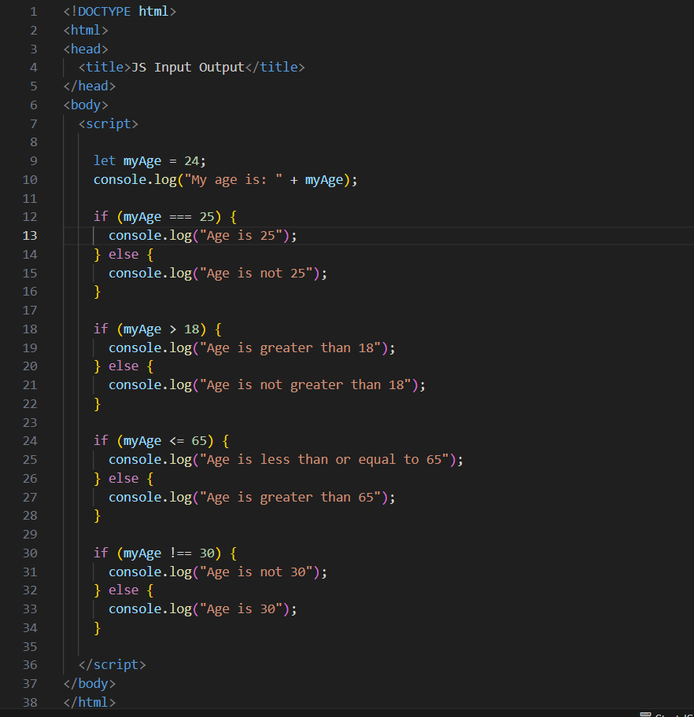**

**Output (test case 1)**

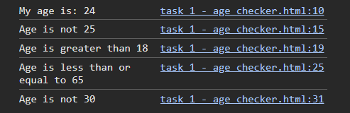

**Observations**

• This version uses **if...else** statements instead of just printing Boolean results.

• Each condition shows a **clear message** based on whether the expression is true or false.

• Helps reinforce how conditional branching works in decision-making.

• Very useful for writing programs that behave differently based on user data or input.